- On Home Screen, Change PG Name to “Mom’s Care PG House”

- Change “Featured” to “Branches”
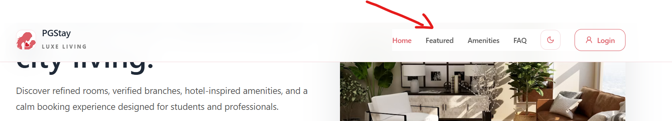

- Remove “48+ Curated PGs”
Change “12 Prime Branches” to “2 Prime Branches”
Change “Aurelia Indiranagar” to “Virugambakkam”

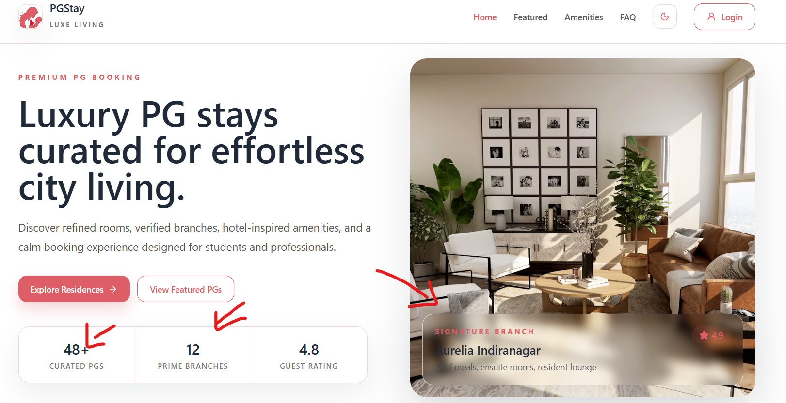

- Connect this Search to two Branches “Virugambakkam and Anna Nagar” and then show “Red Bus” Type Bed Bookings.
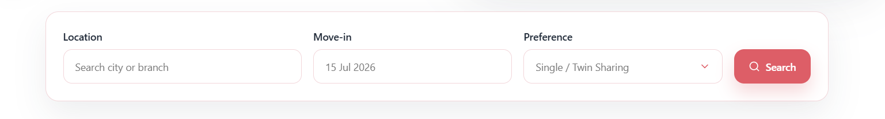

- Mention the above two branch names only here. Remove Porur PG and other locations below. Keep it Neat.
